Rebecca Fuhrer, Kendall Boliba,
Jay Shiogi, Devin Jones, Daniel Thompson
SpMgt 489
Operations Plan

Intro
Our event is Hoops for Heroes. It will consist of a Hoop-a-thon and several competitions. We chose this event because our group has close ties with athletics and people who enjoy competition. There is a strong background of basketball in our group and we believe from prior experience there is much success from hoop-a-thon and related activities. We chose to partner with Marines of the Palouse, who are dedicated to supporting current and past Marines and their families, because it is a well-known and supported foundation in the region and we have great respect for the men and women that serve our country. Also, we will collect used shoes to donate to Playing 4 Kicks, an organization that gives shoes to children and also builds sport courts in the Philippines.
The stakeholders are the Marines of the Palouse, our sponsors, the participants, and University Recreation (UREC), who is providing the facility for our event. The environmental impact is supporting a local charity that supports our local and national heroes. The event is environmentally friendly because it brings people together as a community in a wholesome atmosphere that raises awareness for our cause (Gibson, Lloyd, Bain, & Hottell, 2008). The economic impact benefits the foundation that helps men and women of service get back on their feet and gives shoes to less fortunate children.
Our goal is to raise one thousand dollars for Marines of the Palouse. We also plan to raise awareness for the organization and provide the community with the opportunity to come together and bond. Our objectives are to get a minimum of 50 participants and find sponsors who will contribute as a hoop sponsor. We will encourage participants to collect donations of their own. Along with donations, we have a goal to collect one hundred pairs of athletic shoes to donate to Playing for Kicks.
Venue
The room 144, in the Physical Education Building (PEB) is in compliance with the Americans with Disabilities Act (ADA). There are elevators for people who need wheelchair access, or people who are unable to use the stairs for access into our facility. There is braille on the room numbers and signs in the hallways next to entryways of the gym. Down the hall from our facility there are ADA accessible restrooms for participants to use. We will work to the best of our abilities to accommodate participants and make any alterations to make this event possible for anyone who wants to participate. In one section of the gym we will have limited seating for people who need a break or anyone who just wishes to sit. At our registration table we will let people know they can come up to us and ask for any accommodations they may need and we will work with them. Participants who need additional assistance from a caretaker are welcome to bring assistance through their own arrangements.
Environmental impact & sustainability analysis
We are making our event as environmentally friendly as we can. We will have trash cans and recycle bins located in the gym for disposal of trash and recycling. Since there is no food or drink besides water bottles allowed in the gym our trash accumulation will be kept at a low level.
Discussion of use
The capacity of PEB 144 is under 100 people. We are not expecting to exceed capacity figures in the gym at any one time because we are capping our participant limit at 160 people with no more than ten people participating and a few more in the gym waiting for their turn or playing at the warm up hoop, and all of the staff members running the event. There will be a maximum of two people at each of the hoop-a-thon hoops, one to two shooters at each competition hoop, and the people who are waiting are allowed to be at the open hoop to shoot around before it is their turn. We will encourage people to stay and cheer on their friends and other participants but if it gets too crowded in the gym we reserve the right to ask some people to leave the gym. As people arrive at the event, we will have people wait out in the hallway and our MC will call people in as it is their turn, but that is only if the gym becomes too crowded for the flow of the event. The equipment that will be in the gym is the ball cart to hold the excess basketballs that will not be used during the event. There will be chairs for people to sit in if they want and those will be located in one corner of the gym out of the way of the shooters. The table for registration and the cash box will be located to the side of the doors in the hallway. It is in the hallway due to the limited space within the gym and people will be able to see the registration table as they walk down the hallway to easily locate where the event is.
Human Resources
- Rebounder (3-6) – Persons will rebound the basketball for participants during the 10-minute shooting intervals. There will a rebounder for each participant at the three hoops. We are planning on having two participants per hoop for each 10-minute interval, therefore, two rebounders at each hoop. If we only have one participant shooting at a hoop only one rebounder will be necessary.
- Shot counter (3) – There will be one person per hoop-a-thon hoop that keeps track of made baskets. We will not be keeping track of individual participants, but we will track the total amount made per basket.
- Hoop-a-thon Hoops Monitor (1) – One person will supervise all three hoop-a-thon hoops while keeping the master list of shots made at each hoop. They will be responsible for directing participants who do not know which hoop they are shooting at.
- Registration table (2) – At the entry, there will be a table for check-in and donations. One person will be responsible for checking participants in and collecting entry fees and donations. There will also be a volunteer from Marines of the Palouse at the table to assist with donation collection.
- MC (1) – The MC will manage the sound system. They will be responsible for the music playing and making announcements and shout-outs to sponsors.
- Free throw monitor (1) - At the free throw competition hoop there will be a volunteer that keeps track of the number of free throws made by each participant. If the participant makes seven out of ten free throws the volunteer will give the participant an entry form for the participant to be entered in the prize raffle.
- Three point monitor (1) – At the three-point competition hoop there will be a volunteer that keeps track of the number of three pointers made by each participant. If the participant makes five out of ten three pointers the volunteer will give the participant an entry form for the participant to be entered in the prize raffle.
- Three-point rebounder (1) – One person will be at the three point competition hoop to rebound for the participants. They will be there to assist the participant so the ball does not roll across the gym.
- UREC Supervisor (1) – The UREC Supervisor will supervise the overall facility. They will be responsible for first aid response within their trained abilities.
- Timekeeper (1) – The person will be responsible for keeping the event on track according to our timetable. They will communicate with the MC to announce transitions for the shooting intervals and alerting participants in the hallway who should be shooting.
- Competition and Prize Supervisor (1) – The person will monitor the competition hoops and prizes. They will also be available to assist wherever needed if another part of the event gets backed up or has a problem.
- Photographer (1) – The person will take pictures of the event throughout the day. They will also be brought to the registration table to photograph a head shot of a participant that does not consent to be in photographs on the website.
Recruiting
We will recruit our volunteers first by seeking people we know. Jay and Devin are recruiting their fellow basketball managers to assist with the event. Classmates have emailed our group asking to be volunteers. We have spoken with the Sport Management 290 classes and offered practicum hours to students that wish to volunteer for our event. Lastly, we will reach out to our friends to volunteer our event. We will not turn volunteers away unless we have too many that make the gym too crowded when it comes to staffing numbers.
Management and Evaluation
The volunteers will be asked to come to the event 30 minutes prior to their scheduled volunteer shifts. The first volunteers will arrive at 9:30 a.m. so we can give them a quick overview of what we need them to do. As volunteers arrive for later shifts during the event, they will be directed by the Hoop-a-thon Hoops Monitor and Competition and Prize Supervisor. During the event, they will be overseen by the supervisor of the area they are working at. If they are doing something that needs to be changed, the supervisor will tell them at an appropriate time.

Feedback
After the event we will give the volunteers a survey regarding the event via Facebook. It will be short and concise and cover topics such as what they liked about volunteering for the event and what they think we could do better. The survey can be found in Appendix A. Our group will evaluate each other through staff evaluation forms found in Appendix B.
Organization Hierarchy
A chart of personnel organization can be found in Appendix C.
Planning Logistics
Hoops for Heroes will be registering participants in a few different ways:
- http://spmgt489.weebly.com/hoops-for-heroes.html - Those interested can scroll to the bottom of the page and select a preferred time to come to the event. Someone will select a time for them and e-mail them a confirmation with their shooting time.
- hoopforheroeswsu@gmail.com – Those interested can e-mail us with their name and the time they wish to participate. We will find a shooting time and e-mail them a confirmation with their shooting time.
- https://www.facebook.com/hoopsforheroeswsu - Those interested can message us with their name, e-mail, and the time they wish to participate. We will find a shooting time and e-mail them a confirmation with their shooting time.
Prior to the event, we will e-mail all participants with a schedule outlining the event as a reminder of their shooting time. We will also post open times on our social media pages to let walk-up participants the best time to come shoot.

Staffing Timetable

9:00 am: The UREC Supervisor, Becca, Kendall, Jay, Devin, and Daniel arrive at the gym to start setting up.

9:30 am: The first rounds of volunteers will show up and be trained on their responsibilities. This will include the rebounders, shot counters, free throw monitor, three-point monitor, and three-point rebounder. The Marines of the Palouse volunteer will also show up at this time.

9:45 am: Becca and the Marines of the Palouse volunteer will open up the registration table to check participants in and start taking donations. Devin will begin music on the sound system and start welcoming participants into the gym while giving brief details of how the event works. The photographer will arrive and start taking pictures of the event.

10:00 am: Start hoop-a-thon shooting. The competition hoops will also open at this time, but we do not anticipate many people shooting until after they complete the hoop-a-thon portion. Volunteers will be at each positions working. Kendall will be the timekeeper and communicate with Devin of when to announce the hoop-a-thon shooter switches. Jay will act as the hoop-a-thon hoops monitor. Daniel will be the competition and prize supervisor. Both Jay and Daniel will help each other monitor the entire gym throughout the day.

11:45 am: The second round of volunteers will arrive and be briefed by the Jay and Daniel in their respective areas. Once new volunteers arrive, the morning volunteers will be relieved of their duties during a transition when there is a volunteer there to replace those who need to leave.

10:00 am – 3:30 pm: Participants will shoot the hoop-a-thon portion during their scheduled time of ten minutes. The competition hoops will also be open at this time.

3:30 pm - 3:40 pm: Wrap-up the free throw and three point competition hoops.

3:40 pm – 4:00 pm: Complete the half court competition for participants that are still at the event. Devin will also begin announcing winners of the other competitions.

4:00 pm: The event ends and our group will start cleaning up the gym. Volunteers are welcome to stay and help or they can leave if they need to. The end time is dependent on the schedule of participants. If no one is scheduled to shoot and there are not any walk-ups we will end the event early.

4:05 pm: Shut down the money table and sound system.

4:30 pm: Finish the cleaning and be out of the facility.

Script

9:45 AM: Welcome everyone to the gym

10:00 AM: First Hoop-a-thon Shooters will start

10:10 AM: Shooters end shooting and then transition to second batch of shooters

10:20 AM: Shooters end shooting and then transition to third batch of shooters

This process will continue until 3:20 PM. Between shooters we will mention our sponsors. We have spoken with the sponsors and will use talking points or slogans that promote their business. While people are shooting we will offer words of encouragement. At every 10-minute mark we will be directing people where to go and organizing people. If there are too many people in the gym then we will tell them to leave.

3:40 PM: Half-court shot competition

[During that time: draw for prizes]

4:00 PM: Closing ceremonies, announce winners, thank people for coming, mention sponsors

4:05 PM: Begin clean up

Gantt Chart
A Gantt chart can be found in Appendix D.
Evaluation forms
Participant evaluation forms can be found in Appendix E.
Risk and release wavier
The risk and release can be found in Appendix F.
Risk Management
Many of the risk factors addressed by Raineri & Earl (2005) do not directly apply to sport events because the two studies discussed risk factors in mosh pits at concerts. Some of the risk factors addressed were items being thrown into crowds, items being stolen, being touched or grabbed against ones wishes, alcohol and drug consumption, and large crowd sizes (Raineri & Earl, 2005). The ones that directly relate to sporting events are items being thrown into crowds, alcohol consumption, and items being stolen. During the ‘brawl at the palace’ fans were throwing bottles and other items at players and fans. Also, at most sporting events alcohol is served and with that problems tend to arise. The crowd sizes vary at events but the bigger the crowd the greater the chance for danger. Large crowd sizes make evacuation even tougher.
FIST (Raineri & Earl, 2005)

Force - Our event will have a maximum of 160 participants but they will not be together at one time which helps eliminates crowd force. We anticipate having no more than 35 people in the gym at one time. Eleven of the 35 will be staff or volunteers; there will be three shooters, other participants completing the competition hoops, and friends of the participants there for support.

Information - The crowd at our event may react with enthusiasm and energy when we encourage them to make more shots and play music. Participants may get to rowdy and will need calming down.

Space - PEB 144 is a large gym with ample room around the outskirts of the court and in the middle of the court. At each hoop there should be around 6-9 people, which should allow for maximum spacing. There will be seating on the outside of the court, which will limit space but very minimally.

Time - Our event is scheduled to be around six hours, which will increase the time for incidents to occur. We will need to keep the flow of people moving to try and counter act for the longer event time.
Some foreseeable risks that could happen at our event are alcohol use, crowd problems, and theft. For alcohol use, there is a pretty good chance that we could have people participating in our event who have either had alcohol that day, or be hung over from the night before. If someone is too intoxicated or visibly so, we reserve the right to kick him or her out of the gym. For crowd problems, we are not expecting to have a big crowd in the gym at once. We will filter people through the gym throughout the event. We will still be prepared to handle a large amount of people and prevent the crowd from becoming unruly. For theft, we could have someone try and steal the cash box, donation box, or basketballs and other equipment that we have. We will have people at the door to monitor what people have when they leave the gym. There will always be a group member at the registration table to monitor the cash and donation box. An unforeseeable risk is terrorism. We could potentially encounter a terrorist or a shooter that comes into the gym. The gym is open to the public and we would have a tough time preventing them from coming into the building. We do not anticipate terrorism or a shooter, but we still have to keep it in mind.
Facility risks include damage to the court by people dunking on rims and damaging the hoops or wearing the wrong shoes and leaving marks on the floor. Physical risks include an injury that someone may incur while participating in our event. The main financial risk we face is not getting enough sponsors to cover all of our expenses will still raising an amount of money to donate.
Risk Matrix
The risk matrix can be found in Appendix G .
Incident documentation form
The incident documentation form can be found in Appendix H.
Concessions and Box office
Hoops for Heroes will be allowing participants to register the day of the event. Through walk-up participants and already registered participants we will be handling cash at the door to the event. We will also be collecting monetary donations throughout the event. Hoops for Heroes take full responsibility for all box office duties.
Due to Washington State University policy regarding the PEB, no food will be permitted in the gymnasium. However, capped, spill-proof water bottles are permitted. Other beverages will not be permitted in the gymnasium. In case of any confusion, there will be an area outside the gym in the hallway where food and beverages other than water can be consumed. Hoops for Heroes will have the right to ask anyone to leave that are not following Washington State University and Hoops for Heroes rules and regulations. Due to rules regarding food and beverage we will not have any concession responsibilities. The facility will have no box office or concession responsibility.
Hoops for Heroes have a strict no alcohol policy. Due to the fact that we will have participants under the age of twenty-one we will keep the event alcohol free. Hoops for Heroes have the right to ask anyone that is visibly drunk to leave the premises.
Conclusion
With this event we will bring an increased awareness to Marines of the Palouse and raise money for this local charity. The word will spread to high school and college aged students as well as parents and family members of the high school aged kids. This event will bring people together to have fun and also achieve the common goal of raising money this organization.

Works Cited
Getz, D. (2005). Event management & event tourism (2nd ed.). Elmsford, NY: Cognizant Communication.
Gibson, F., Lloyd, J., Bain, S., & Hottell, D. (2008). Green design in sustainability in sport and recreation facilities. The SMART Journal, 4(2), 26-33.
Raineri, A., & Earl, C. (2005, June). Crowd Management for Outdoor Music Festivals. Occupational Health and Safety, 21(3), 205-215.

Appendix A
Volunteer Evaluation

Please rate the event on a scale of 1 to 10
10 is excellent; 1 is poor

The organization of the event:

1 2 3 4 5 6 7 8 9 10

The level of participation by contestants:

1 2 3 4 5 6 7 8 9 10

Do you feel your job was helpful to the event?

1 2 3 4 5 6 7 8 9 10

What can we do to improve the structure of the event and timeline?

Is there a way we could improve the event for the participants?

Is there a way we could improve the event for you, the volunteer?

Appendix B
Group Member Evaluation

Please rate each member on a scale of 1 to 10
10 is excellent; 1 is poor

The attendance and communicate of the individual:

1 2 3 4 5 6 7 8 9 10

The level of contribution to group work:

1 2 3 4 5 6 7 8 9 10

The quality of work contributed to the assignments and event:

1 2 3 4 5 6 7 8 9 10

The effectiveness of the individual in their tasks and responsibilities at the event:

1 2 3 4 5 6 7 8 9 10

What is one (or multiple) area that the individual can improve on?

Appendix C

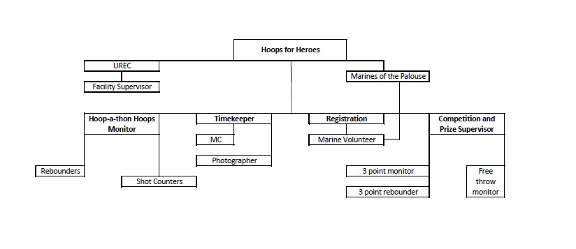
Appendix D
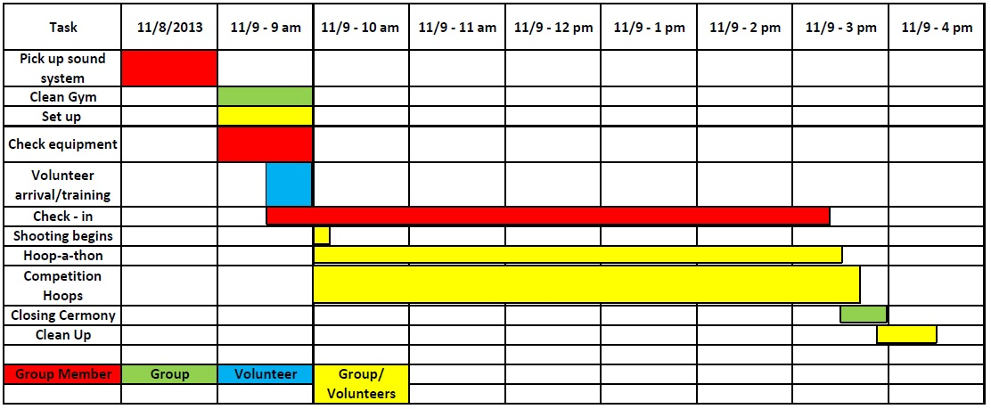
Appendix E
Participant Evaluation:

Please rate the event on a scale of 1 to 5
5 being excellent; 1 being poor
Would you participate in another hoop-a-thon after this event?
1 2 3 4 5
Prior to today’s event were you aware of Marines of the Palouse?
1 2 3 4 5
How likely would you be to attend other Marines of the Palouse charity event?
1 2 3 4 5
How likely would you be to donate money to Marines of the Palouse if it were not for our event?
1 2 3 4 5
Is there anything about this event that you would like to see improved upon if there is another hoop-a-thon event?

Appendix F
Hoops for Heroes
ASSUMPTION OF RISK AND RELEASE OF LIABILITY
PLEASE READ BEFORE SIGNING

I _______________________________, hereby agree that by participating in “Hoops for Heroes,” that I assume all reasonable risks associated with this activity. I agree to release “Hoops for Heroes” (including all staff and volunteers) of any liabilities and agree to participate under my own will. I release Washington State University, University Recreation, the College of Education, and the Sport Management Department of any and all liabilities that may occur due to my participation in or any actions resulting from attending the “Hoops for Heroes” event. I understand that by participating in this event I expose myself to the risk of potential injury. Furthermore, I recognize that the actions of other people either affiliated or not affiliated with Washington State University or “Hoops for Heroes” may cause harm or property damage. I also agree that anyone involved as staff or volunteers for “Hoops for Heroes” may ask me to leave the premises at any time if they deem necessary.

Release of Image
I agree to release my image and likeness, allowing “Hoops for Heroes” to use any photographs or video of myself while at the event on their website for educational purposes. My image and likeness will not be used for profit. Please check one of the following options below:

I consent: ________ I do not consent________

I have carefully read this Assumption of Risk and Release of Liability and fully understand its contents. I agree to and understand the terms and conditions and agree to sign this under my free will.

Signature:_______________________________________ Date:_______________

Printed Name:_____________________________________________________

If the participant is a minor, please have a parent or guardian sign:

Signature:_______________________________________ Date:_______________

Printed Name:_____________________________________________________

Appendix G
Paper cut/scratch
Sore from shooting shots
Hit in the body with ball
Knee on knee blow from participant
Jammed finger from catching pass
Hit in head with basketball from rebound
Breaking neck from hanging and falling from rim
Turn ankle on ball
Low Impact
Moderate Impact
Collision with participant or volunteer
Severe Impact
Very Unlikely
Might Occur
Almost Certain
To Occur
Probability
Severity of
Impact
Appendix H

Incident Documentation Form

Name: _____________________________________________________
Address: ___________________________________________________
Phone: _____________________________________________________
Date of Birth: ______ Minor: Y / N
If yes, name of legal guardian: __________________________________
Phone: ______________________ Relation to participant:_______________________
Supervising Staff: ____________________________________________
Date and Time: ______________________________________________
Where did the incident/injury occur?
____________________________________________________________________________________________________________________________________________________________
Incident/Injury (be specific): __________________________________________________________________________________________________________________________________________________________________________________________________________________________________________
First Aid given: ____________________________________________________________________________________________________________________________________________________________
Was professional medical care called? Y / N
Why or why not? __________________________________________________________________________________________________________________________________________________________________________________________________________________________________________
Status of Participant after aid/treatment:
____________________________________________________________________________________________________________________________________________________________
Participant/Guardian Signature: ______________________________________________
Group Member Signature: __________________________________________________
UREC Supervisor Signature: ________________________________________________

